Project 0 - Legged Locomotion Robot

EECS 464 - Winter 2018

**Final Report**

February 9, 2018

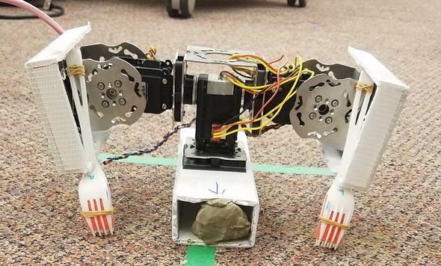

Team Blue:

Royce Chung

Anne Gu

Mukai Wang

Ali Yassine

Course Instructor:

Prof. Shai Revzen

**TABLE OF CONTENTS**

|  |  |
| --- | --- |
| 1. Background …..…………...………………………………………………….... | pg. 2 |
| 1.1 Problem Description |  |
| 1.2. Brainstorming |  |
| 1.3. Final Design………………………………………………………………. | s |
| 2. Results ..….………………………….…………………………………………. | pg. 2 |
| 3. Discussion…………….…………………………………………………………. | pg. 2 |
| 4.References ………………………………...…………………………………...... | pg. 2 |

**1. BACKGROUND**

**1.1 Problem Description**

**In LaTeX**

**1.2 Brainstorming**

The objectives we had for our robot were:

* Meeting the structural requirements
* Being able to move one meter in a straight line in 30 seconds or less
* Being able to turn in place with a turning radius less than 6 inches
* Minimizing robot size
* Maximizing durability

In order to achieve those goals, we reviewed robots from previous years and studied the ones that matched our objectives well. We found that 3 teams prior to ours achieved our objectives. The first team we found was the Gorilla bot from Fall 2013, which used two servo motors to propel the robot with “Gorilla arms,” using two

However, this year was the first year in Hands On Robotics where teams were allowed to use 3 servo motors, unlike previous years. Therefore, we decided to research different ways to move the robot by combining designs from previous years with new motions inspired by wildlife.

We studied the water strider, an insect that floats on water, using its front legs to propel itself on water and hind legs to steer.

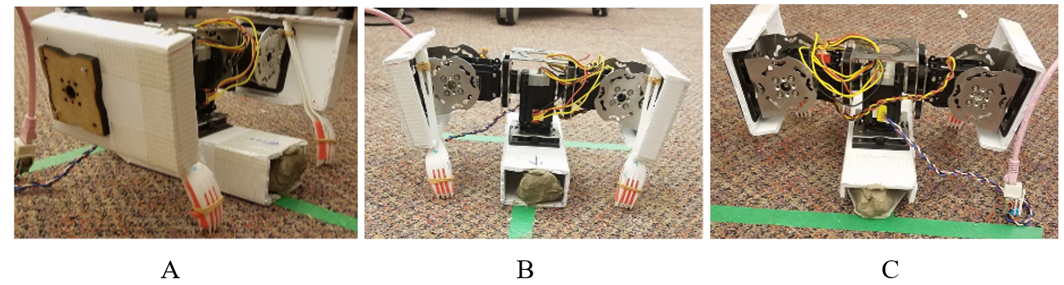

**Figure 1.** Complete robot assembly: A) Side view, B) Front view, C) Back view

**2. RESULTS**

P-day had four different events. First, was the qualification round where the robot had to move from one end of the track to the other in a line ignoring the marker tape. The next event was a race around the figure eight track with inner and outer bounds. The third event was the same as the previous figure eight track race, but only the inner bound applied. The last event was a race along a 15’ straight track.

2.1 Qualification

In the qualification round each team’s robot had to move from one end of the track to the other. Green team took 39 seconds to complete the qualification, Red team took 57 seconds, and Blue team took 29 seconds.

2.2 Figure Eight Track (Inner and Outer Bounds)

The following table details the time each robot took to complete the figure eight track while staying within the inner and outer bounds of the track. Times with (DQ) means the robot exceeded the bounds while completing the track. Red team recorded the fastest time of 63 seconds.

|  |  |  |  |  |  |
| --- | --- | --- | --- | --- | --- |
|  | Trial 1 (sec) | Trial 2 (sec) | Trial 3 (sec) | Trial 4 (sec) | Trial 5 (sec) |
| Green Team | 134 (DQ) | 143 | - | 111(DQ) | 133 |
| Red Team | - | 76 (DQ) | 67 | - | 63 |
| Blue Team | 160 (DQ) | - | 153 (DQ) | 127 | - |

Table XX: P-Day race result for all teams in the figure eight track with inner and outer bounds.

2.3 Figure Eight Track (Only Inner Bounds)

The following table details the time each robot took to complete the figure eight track while staying within the inner bounds of the track. Times with (DQ) means the robot exceeded the inner bounds while completing the track. Red team recorded the fastest time of 44 seconds.

|  |  |  |  |  |  |
| --- | --- | --- | --- | --- | --- |
|  | Trial 1 (sec) | Trial 2 (sec) | Trial 3 (sec) | Trial 4 (sec) | Trial 5 (sec) |
| Green Team | - | 140 (DQ) | 110 (DQ) | - | 83 |
| Red Team | 63 | - | 65 | 61 | 44 |
| Blue Team | 151 | 153 (DQ) | - | 166 (DQ) | - |

Table XX: P-Day race results for all teams in the figure eight track with only inner bounds.

2.4 15’ Straight Track Race

The following table details the time each robot took to complete the 15’ straight track. DNF (Did not finish) means the robot failed to finish the race. Green team finished the straight track race with the fastest time of 38 seconds.

|  |  |  |  |  |  |
| --- | --- | --- | --- | --- | --- |
|  | Trial 1 (sec) | Trial 2 (sec) | Trial 3 (sec) | Trial 4 (sec) | Trial 5 (sec) |
| Green Team | - | DNF | - | 38 | 38 |
| Red Team | 39 | 69 | 44 | - | 42 |
| Blue Team | 76 | - | 73 | 54 | - |

Table XX: P-Day race results for all teams in the straight track.

2.5 Other Designs

2.5.1 Green Team

Green team’s design was a crawler, it used two arms with directional friction pads to shuffle forward. A third motor in the center of the robot was used for steering. The motor would dig a spike into the ground on the side of the robot, allowing the robot to turn.

2.5.2 Red Team

Red team’s design was a crawler design that resembled a snake. It used two motors to drive an array of forks that dug into the carpet to propel the robot forward. The third motor was used to rotate the body allowing the robot to move in different directions.

**3. DISCUSSION AND FUTURE WORK**

In this section, we analyze the results, described in the previous section, and discuss potential improvements for each P0 robot.

**3.1 Analysis of our robot**

Out of the six figure eight track rounds, our robot was disqualified four times.

In the straight track race, our robot was, on average, the slowest.

There were two disadvantages to our robot were slow turn time and slipping frequency. It took 7.5±.5 seconds for our robot to turn 90 degrees. Potential improvements for turning including adding features to the side of the fork to increase_____.

Another area of improvement for our robot is decreasing the slipping frequency.

* Turning was time consuming. Turns were primarily the reason why we got disqualified so often
  + Turn radius was “wide”
  + Improvements can include adding features to the side of the fork, such as bamboo skewers or knives.
* Our robot slipped a lot. Localized, Friction based movements. Especially on tape
  + The back end of the base of our robot was worn down from testing, ended up adding a knife at the end to help prevent the slipping. Using the leg padding from the other team, helped us realize that directional friction was needed, but ultimately using the padding prevented us from turning.
  + Tried also to mitigate it by adding weight to the base.
* Robot did not have good durability
* Our robot has localized, friction based movements and a dynamic gait.
* Maybe mention that our robot was probably the easiest to manufacture?
* Dynamic gate ⇒ More instability?
* Mitigated forks from breaking by adding a second fork.
  + Could also try metal forks or bamboo forks, etc.
* Discuss weighted clay? Stability issues?
* Our robot was probably the smallest out of the entire team
* “It was also noted that when either arm of the robot made its pulling motion across the ground the forks slipped across the carpet without making full purchase. This slipping is lost energy and probably slowed the robot. Two possible remedies for this slipping seem apparent and may be worth examining. First, the team could decrease the motor actuation speed on each arm pull to allow the forks to gain better purchase. Additionally, mass could be added to the arms to increase the normal force on the forks against the carpet.”
* Our robot’s stride length and stride times were slow compared to other teams (potentially because the size of our robot was the smallest.)
  + Our design could potentially have been better if we made our legs longer.

**3.2 Analysis of other team’s robots**

3.2.1 Red Team

Red team’s robot had the best overall performance in the figure eight track trials and the second fastest time in the straightaway race. Their robot uses a scuttling motion to move and feet asymmetrical friction

Their only disqualification on P-day occured because one of the feet fell off, which made steering difficult. In their How-To documentation, they mention that the feet are hot glued to the legs. Figuring out a way to better fasten the feet onto the legs could improve their robot’s durability.

Some advantages to their design includes their use of asymmetric friction with the design of their feet and stable structure.

* Drifted to the right?
* Biggest advantage might have been their use of friction and stability (4 legs on the ground )
  + Scuttling movement
  + Had
  + The goal of this component is to allow for asymmetric friction between the base of the legs and the surface of the carpet. To do so, a grid of pointed spikes is angled away from the intended of motion such that the spikes snag when the robot is pushing itself forward, and slide when the leg is resetting its position.
* Varying different materials for the feet?
* Optimize the width of the robot - tradeoff between risk of being disqualified and faster strides

3.2.2 Green Team

Similar to our robot, green team’s robot disqualified four out of the six trials on the figure eight track. One potential explanation is that their robot had the longest fully extended length (## vs ## and ##), and as a result, the longest stride length. This may have made turning without being disqualified difficult. However, having a long stride length was advantageous in the straightaway race, as their robot had the fastest time on average. Reducing the overall length of the robot could reduce the risk of disqualification.

Another explanation _____.

* Disqualified often in the figure 8 track, partially do to it’s long length (Stroke length). Made it easy to over step bounds.
  + Linkages were large, and when they turned that made it difficult
* Had more degrees of freedom? Had a greater range of motion? There were a lot of different things you had to control.
* Complexity of robot - Had a variety of “behaviors”
* Each joint had to be actuated separately? The movement was not synchronized?
* Stacked forks lead to slower time in moving forward?
  + Reducing the number of forks needed or adjusting how close the forks are to each other

**4. References**